LOAN APPROVAL

Screen Shots

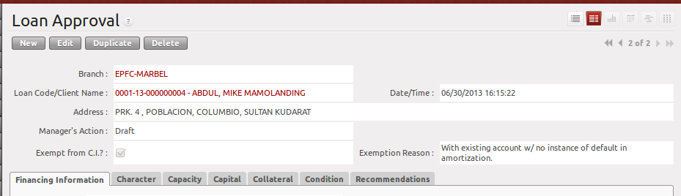

Financing Information and 5C's

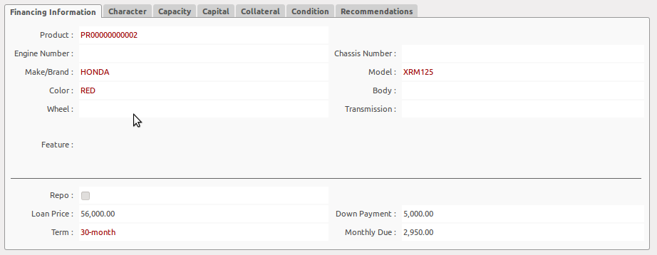
All the information encoded by the Credit Investigator will be viewed by the Branch Manager for review.

CI's Recommendation
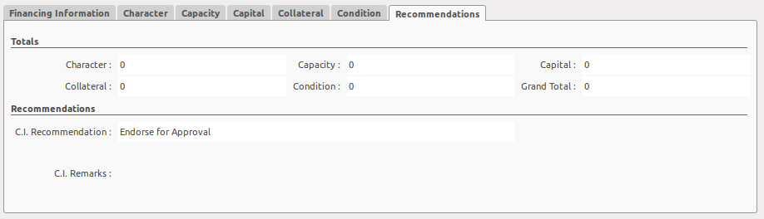
The CI's Recommendation is summarized in one tab for Branch Manager's review

BM's Remarks and Buttons
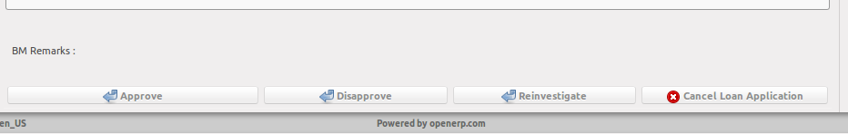

The Branch Manager should encode the remarks specially for disapproved loan applications.

Approve Button
When clicked, it will automatically create a record to Purchase Order and will change the Loan Status to “Loan Approved”

Disapprove Button
Will change the Loan Status to “Disapproved”.

Reinvestigate Button
Will change the Loan Status to “For Reinvestigation”.

Cancel Loan ApplicationButton
Will change the Loan Status to “Cancelled Loan Application” if the customer decided not to push through the loan application.

Validations:
- only the records of the branch can be viewed by the Branch Manager.

